Charlie Nitschelm

Thermal Systems

12/10/2018

Homework 5

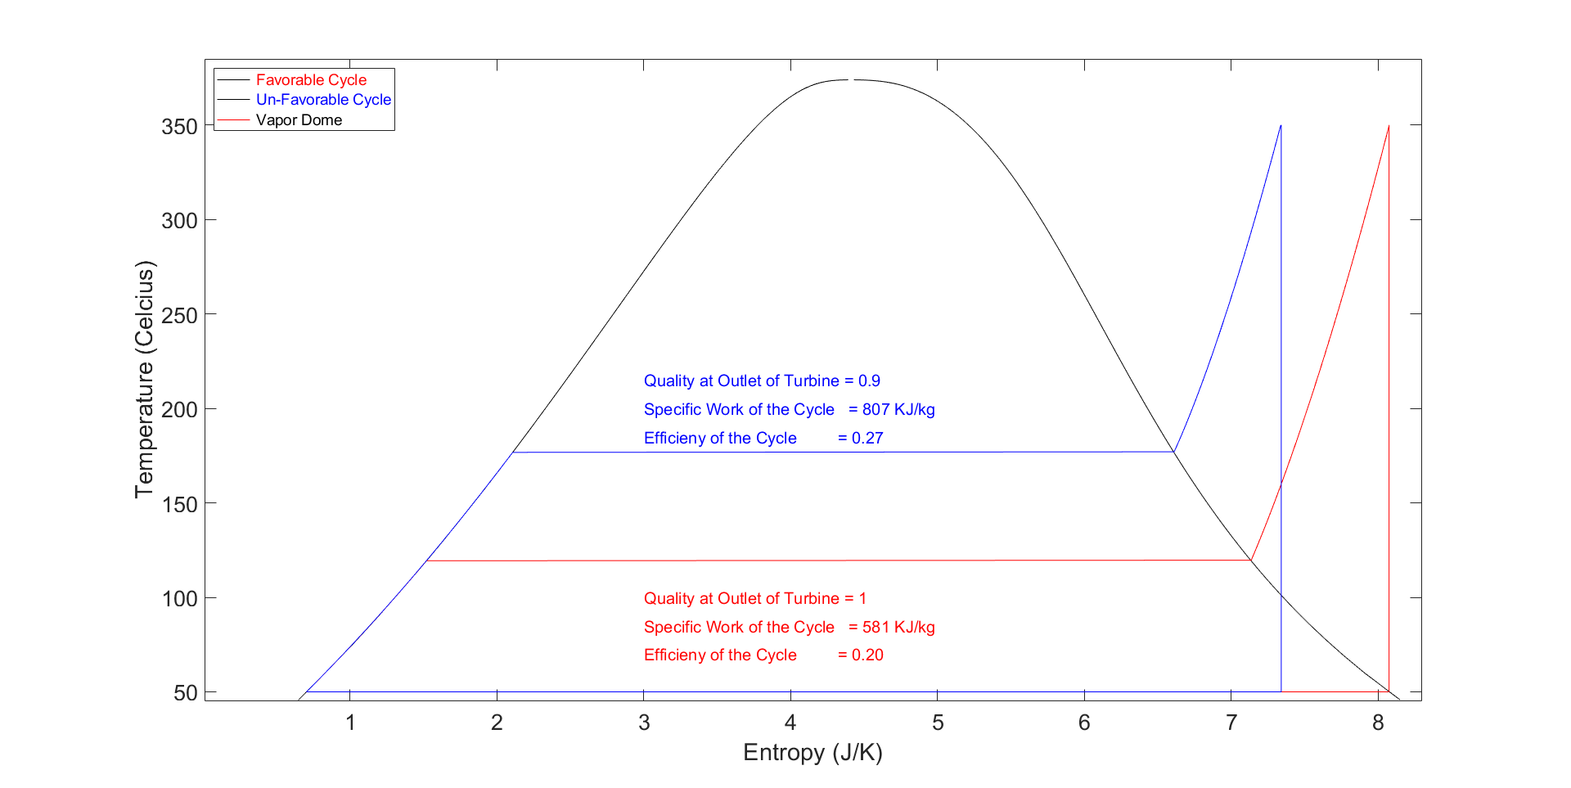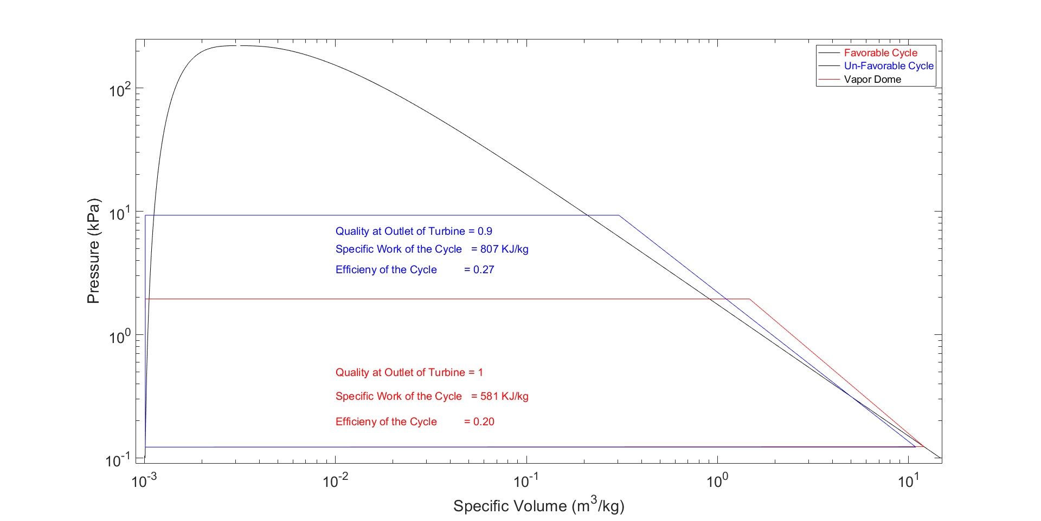

I chose to graph two different cycles. One that is more efficient, but ends with a mixture within the turbine, and one that is slightly less efficient but has vapor throughout the entire turbine. Thanks for everything this semester, hope your winter break is relaxing.

# Appendix – One Script

clear all

close all

%%%%%%

% Definition of Constants

%%%%%%

R=0.287; % Constant

PR = 20;

PR2 = 113;

%%%%%%%%%%%%%

% Calculations of the Vapor Dome for the Refridgeration Cycle

% Will be plotted as a T-s and P-h Diagram

% Two curves will be plotted for each graph, one for the Saturated Liquid and one for Saturdated Vapor Sections

%%%%%%%%%%%%%

% Constant Variables and Pressure Array to Calculate Graph Values

Q_SL = 0; % Saturated Liquid

Q_SV = 1; % Saturated Vapor

P_SL_SV = linspace(.00001,1000,10000); % Pressures for the Saturated Liquid Curve

S_SL = zeros(length(P_SL_SV),1);

T_SL = zeros(length(P_SL_SV),1);

V_SL = zeros(length(P_SL_SV),1);

H_SL = zeros(length(P_SL_SV),1);

S_SV = zeros(length(P_SL_SV),1);

T_SV = zeros(length(P_SL_SV),1);

V_SV = zeros(length(P_SL_SV),1);

H_SV = zeros(length(P_SL_SV),1);

% Looping 1000 times to provide values for the Vapor Dome Curves for T, s, h and v. P array will be graphed with them

for index=1:10000

H_SL(index) = XSteam('hL_P',P_SL_SV(index));

S_SL(index) = XSteam('sL_P',P_SL_SV(index));

T_SL(index) = XSteam('T_hs',H_SL(index),S_SL(index));

V_SL(index) = XSteam('vL_P',P_SL_SV(index));

H_SV(index) = XSteam('hV_p',P_SL_SV(index));

S_SV(index) = XSteam('sV_p',P_SL_SV(index));

T_SV(index) = XSteam('T_hs',H_SV(index),S_SV(index));

V_SV(index) = XSteam('vV_p',P_SL_SV(index));

end

tempdome = [T_SL,T_SV];

entrdome = [S_SL,S_SV];

voludome = [V_SL,V_SV];

presdome = [P_SL_SV];

%%%%%%

% State Calculations

%%%%%%

% State 1 % Inlet of Pump - Both Desirable and Un-Desirable

T1 = 50;

x = 0;

s1 = XSteam('sL_T',T1);

h1 = XSteam('hL_T',T1);

v1 = XSteam('vL_T',T1);

P1 = XSteam('p_hs',h1,s1);

% State 4 % Inlet of Condensor - Desirable

T4 = T1;

x4 = 1;

h4 = XSteam('hV_T',T4);

s4 = XSteam('sV_T',T4);

v4 = XSteam('vV_T',T4);

P4 = XSteam('P_hs',h4,s4);

% State 4 % Inlet of Condensor - Un-Desirable

T4u = T1;

xu4 = .9;

P4u = P1;

h4u = XSteam('h_Tx',T4u,xu4);

s4u = XSteam('s_ph',P4u,h4u);

v4u = XSteam('v_ph',P4u,h4u);

% State 2 % Inlet of Boiler - Desirable

P2 = 1.95;

s2 = s1;

h2 = XSteam('h_ps',P2,s2);

v2 = XSteam('v_ps',P2,s2);

T2 = XSteam('T_ps',P2,s2);

% State 2 % Inlet of Boiler - Un-Desirable

P2u = 9.3;

s2u = s1;

h2u = XSteam('h_ps',P2u,s2u);

v2u = XSteam('v_ps',P2u,s2u);

T2u = XSteam('T_ps',P2u,s2u);

% State 3 % Inlet of Turbine - Desirable

s3 = s4;

P3 = P2;

T3 = 350;

h3 = XSteam('h_ps',P3,s3);

v3 = XSteam('v_ps',P3,s3);

% State 3 % Inlet of Turbine - Un-Desirable

s3u = s4u;

P3u = P2u;

T3u = 350;

h3u = XSteam('h_ps',P3u,s3u);

v3u = XSteam('v_ps',P3u,s3u);

% Boiler Process

T_Boiler = linspace(T2,T3,1000);

T_Boileru = linspace(T2u,T3u,1000);

P_Boiler = P2;

P_Boileru = P2u;

s_Boiler = zeros(1000);

v_Boiler = zeros(1000);

s_Boileru = zeros(1000);

v_Boileru = zeros(1000);

for index = 1:1000

s_Boiler(index) = XSteam('s_pT',P_Boiler,T_Boiler(index));

v_Boiler(index) = XSteam('v_pT',P_Boiler,T_Boiler(index));

s_Boileru(index) = XSteam('s_pT',P_Boileru,T_Boileru(index));

v_Boileru(index) = XSteam('v_pT',P_Boileru,T_Boileru(index));

end

%Desirable

tempspump = [T1,T2];

entropypump = [s1,s2];

tempsturb = [T3,T4];

entropyturb = [s3,s4];

tempscond = [T4,T1];

entropycond = [s4,s1];

%Un-Desirable

tempspumpbad = [T1,T2u];

entropypumpbad = [s1,s2u];

tempsturbbad = [T3u,T4u];

entropyturbbad = [s3u,s4u];

tempscondbad = [T4u,T1];

entropycondbad = [s4u,s1];

%Desirable

volspump = [v1,v2];

prespump = [P1,P2];

volsturb = [v3,v4];

presturb = [P3,P4];

volscond = [v4,v1];

prescond = [P4,P1];

%Un-Desirable

volspumpbad = [v1,v2u];

prespumpbad = [P1,P2u];

volsturbbad = [v3u,v4u];

presturbbad = [P3u,P4u];

volscondbad = [v4u,v1];

prescondbad = [P4u,P1];

P_Boiler = zeros(1000,1);

P_Boiler(1:1000) = P2;

P_Boileru = zeros(1000,1);

P_Boileru(1:1000) = P2u;

%%%%%%

% Efficiency, specific net work and qualioty at the turbine outlet for each cycle calculation

%%%%%%

% Good case calcs

Quality_Good = 1;

q_h_good = h3-h2;

q_l_good = h4-h1;

eff_good = (q_h_good - q_l_good) / q_h_good;

w_good = q_h_good - q_l_good;

% Bad case calcs

Quality_Bad = .9;

q_h_bad = h3u-h2u;

q_l_bad = h4u-h1;

eff_bad = (q_h_bad - q_l_bad) / q_h_bad;

w_bad = q_h_bad - q_l_bad;

figure(1) % T-s

plot(entrdome,tempdome,'k')

hold on

plot(entropypump,tempspump,'r',s_Boiler,T_Boiler,'r',entropyturb,tempsturb,'r',entropycond,tempscond,'r')

plot(entropypumpbad,tempspumpbad,'b',s_Boileru,T_Boileru,'b',entropyturbbad,tempsturbbad,'b',entropycondbad,tempscondbad,'b')

xlabel('Entropy (J/K)','FontSize',22)

set(gca,'fontsize',20)

ylabel('Temperature (Celcius)','FontSize',22)

set(gca,'fontsize',20)

text(3,215,'Quality at Outlet of Turbine = 0.9','Color','b','FontSize',15)

text(3,200,'Specific Work of the Cycle = 807 KJ/kg','Color','b','FontSize',15)

text(3,185,'Efficieny of the Cycle = 0.27','Color','b','FontSize',15)

text(3,100,'Quality at Outlet of Turbine = 1','Color','r','FontSize',15)

text(3,85,'Specific Work of the Cycle = 581 KJ/kg','Color','r','FontSize',15)

text(3,70, 'Efficieny of the Cycle = 0.20','Color','r','FontSize',15)

xlim([.01 8.3])

ylim([45 385])

lgd = legend('\color{red} Favorable Cycle','\color{blue} Un-Favorable Cycle','\color{black} Vapor Dome','Location','northwest');

lgd.FontSize = 14;

hold off

figure(2) % p-v

loglog(voludome,presdome,'k')

hold on

loglog(volspump,prespump,'r',v_Boiler,P_Boiler,'r',volsturb,presturb,'r',volscond,prescond,'r')

loglog(volspumpbad,prespumpbad,'b',v_Boileru,P_Boileru,'b',volsturbbad,presturbbad,'b',volscondbad,prescondbad,'b')

xlabel('Specific Volume (m^3/kg)','FontSize',22)

set(gca,'fontsize',20)

ylabel('Pressure (kPa)','FontSize',22)

set(gca,'fontsize',20)

text(.01,7,'Quality at Outlet of Turbine = 0.9','Color','b','FontSize',15)

text(.01,5,'Specific Work of the Cycle = 807 KJ/kg','Color','b','FontSize',15)

text(.01,3.4,'Efficieny of the Cycle = 0.27','Color','b','FontSize',15)

text(.01,.5,'Quality at Outlet of Turbine = 1','Color','r','FontSize',15)

text(.01,.32,'Specific Work of the Cycle = 581 KJ/kg','Color','r','FontSize',15)

text(.01,.20, 'Efficieny of the Cycle = 0.20','Color','r','FontSize',15)

xlim([.0009 15])

ylim([0.09 250])

lgd = legend('\color{red} Favorable Cycle','\color{blue} Un-Favorable Cycle','\color{black} Vapor Dome');

lgd.FontSize = 14;

hold off